**THE SUPERIOR COLLEGE LAHORE**



**Faculty of Computer Science & IT**

**Department of Information Technology**

**Final Year Project REPORT**

Online Grocery Store

Project ID: **FYP-F19-E008**

**Project Team**

|  |  |  |  |
| --- | --- | --- | --- |
| **Student Name** | **Student ID** | **Program** | **Email Address** |
| M Arslan | MCSW-F19-037 | MCS | [Mcsw-f19-037@superior.edu.pk](mailto:Mcse-f19-049@superior.edu.pk) |
| Maryam Umer | MCSE-F19-021 | MCS | [Mcse-f19-021@superior.edu.pk](mailto:Mcse-f19-032@superior.edu.pk) |
| Shahbaz Khan | MCSM-F19-155 | MCS | [Mcsm-f19-155@superior.edu.pk](mailto:Mcse-f19-004@superior.edu.pk) |

**Mr. Arif**

Lecturer

**Project Report**

Online Grocery Store

**Change Record**

|  |  |  |  |  |
| --- | --- | --- | --- | --- |
| **Author(s)** | **Version** | **Date** | **Notes** | **Supervisor’s Signature** |
|  | 1.0 |  | <Original Draft> |  |
|  | 1.1 |  |  |  |
|  |  |  | <Changes Based on Feedback from Faculty> |  |
|  |  |  | <Added Project Plan> |  |
|  |  |  | <Changes Based on Feedback from Supervisor> |  |
|  |  |  |  |  |
|  |  |  |  |  |
|  |  |  |  |  |
|  |  |  |  |  |
|  |  |  |  |  |

**APPROVAL**

|  |  |
| --- | --- |
| **Project Supervisor** | |
| Comments: ___________________________________________________________________ | | |
| _____________________________________________________________________________ | | |
| Name: ______________________________ |  | |
| Date: _______________________________ | Signature: __________________________ | |

|  |  |
| --- | --- |
| **Project Manager** | |
| Comments: ___________________________________________________________________ | |
| _____________________________________________________________________________ | |
|  |  |
| Date: _______________________________ | Signature: __________________________ |

|  |  |
| --- | --- |
| **Head of the Department** | |
| Comments: ___________________________________________________________________ | |
| _____________________________________________________________________________ | |
|  |  |
| Date: _______________________________ | Signature: __________________________ |

# 

# Dedication

**TO**

**HAZRAT MUHAMMAD (****),**

**REVEREND PARENTS**

**&**

**FAMILY and Friends**

**WITH WHOSE EFFORTS, GUIDANCE, LOVE AND**

**PRAYERS, I HAVE BEEN ABLE TO REACH**

**THIS STAGE**

**OF MY**

**LIFE**

.

# Acknowledgements

We would like to thank Our Supervisor for his constant guidance and help throughout the project. We would also like to thank Project Manager for graciously accepting to be on my committee. Finally, we would like to thank my family and my friends for all the support and encouragement.

# Executive Summary

Web is the rapidest developing media during the previous decade. Particularly, on the web shopping is a quickly developing web-based business territory. Online stores are as a rule accessible 24 hours per day, and numerous buyers have Internet access both at work furthermore, at home. A fruitful web store isn't only a gorgeous site with dynamic specialized highlights, recorded in many web crawlers but a good site will help the customer to providing them the ease of use and reliability more over to make new opportunity for our self to earn we also help to provide business plat forms to other .We are going to make an online shopping store, Basically we are going to make a biggest platform of clothing where all brands can sale their clothes and also small business who need platform to sale their clothes also. We are going to promote and serve different brands all over the world. Where everyone can visit and choose their clothes with their own choice. It’s helpful for people that all brands can available on one platform. Who wants to earn money more than regular routine to sale their item but they don't have any platform? In this website customer can visit and select their brand to shop and if he / she wants to look all the brands all together they can also do this so and more they can select a prize range and in that selected range all the products available equal to or less than the selected range and displayed on the screen to the customer by this Customer can make the right selection due to more verity at one platform and in this way the not more popular brands articles are also on screen that is a good opportunity for the small scale shop keepers to sale their good products.

# Table of Contents

Online Shopping Store i

Final Year Project i

Session 2019-2021 i

Masters in Computer Sciences i

Plagiarism Free Certificate ii

Dedication v

Acknowledgements vi

Executive Summary vii

Table of Contents viii

List of Figures xii

List of Tables xiii

Chapter 1 1

Introduction 1

1.1. Background 2

1.2. Motivations and Challenges 3

1.3. Goals and Objectives 3

1.4. Literature Review/Existing Solutions 3

1.5. Gap Analysis 4

1.6. Proposed Solution 4

1.7. Project Plan 4

1.7.1. Work Breakdown Structure 5

WBS 5

1.7.2. Roles & Responsibility Matrix 6

1.7.3. Gantt Chart 7

1.8. Report Outline 7

Chapter 2 8

Software Requirement Specifications 8

2.1. Introduction 9

2.1.1. Purpose 9

2.1.2. Document Conventions 9

2.1.3. Intended Audience and Reading Suggestions 9

2.1.4. Product Scope 10

2.1.5. References 10

2.2. Overall Description 10

2.2.1. Product Perspective 10

2.2.2. Product Functions 10

2.2.3. User Classes and Characteristics 11

2.2.4. Operating Environment 11

2.2.5. Design and Implementation Constraints 12

2.2.6. User Documentation 12

2.2.7. Assumptions and Dependencies 12

2.3. External Interface Requirements 13

2.3.1. User Interfaces 13

2.3.2. Hardware Interfaces 18

2.3.3. Software Interfaces 18

2.3.4. Communications Interfaces 18

2.4. System Features 18

2.4.1. Login/Logout 18

2.4.1.1. Description and Priority 18

2.4.1.2. Stimulus/Response Sequences 19

2.4.1.3. Functional Requirements 19

2.4.2. Email 19

2.4.2.1. Description and Priority 19

2.4.2.2. Stimulus/Response Sequences 19

2.4.2.3. Functional Requirements 19

2.4.3. Message Service 20

2.5. Other Nonfunctional Requirements 20

2.5.1. Performance Requirements 20

2.5.2. Safety Requirements 21

2.5.3. Security Requirements 21

2.5.4. Software Quality Attributes 21

2.5.5. Business Rules 21

2.6. Other Requirements 22

Chapter 3 23

Use Case Analysis 23

3.1. Use Case Model 24

3.2. Use Case Descriptions 25

Chapter 4 28

System Design 28

4.1. Architecture Diagram 29

4.2. Domain Model 30

4.3. Entity Relationship Diagram with data dictionary 31

4.4. Class Diagram 32

4.5. Sequence / Collaboration Diagram 33

4.6. Operation contracts 36

4.7. Activity Diagram 40

4.8. State Transition Diagram 43

4.9. Component Diagram 44

4.10. Deployment Diagram 45

4.11. Data Flow diagram [*only if structured approach is used - Level 0 and 1*] 46

Chapter 5 50

Implementation 50

5.1. Important Flow Control/Pseudo codes 51

5.2. Components, Libraries, Web Services and stubs 52

• Responsive design 52

• Understandable and Remarkable Logo 52

• User-Friendly 52

• Good and usable Shopping cart 52

5.3. Deployment Environment 53

5.4. Tools and Techniques 53

5.5. Best Practices / Coding Standards 54

5.6. Version Control 54

Chapter 6 55

Testing and Evaluation 55

6.1. Use Case Testing 56

6.1.1 use case 56

6.2. Equivalence partitioning 65

6.3. Boundary value analysis 65

6.4. Data flow testing 66

6.5. Unit testing 66

6.6. Integration testing 66

6.7. Performance testing 66

6.8. Stress Testing 66

Chapter 7 69

Summary, Conclusion and Future Enhancements 69

7.1. Project Summary 70

7.2. Achievements and Improvements 70

7.3. Critical Review 70

7.4. Lessons Learnt 71

7.5. Future Enhancements/Recommendations 71

Appendices 72

Appendix A: User Manual 73

Appendix B: Admin Panel / Venders Panel 74

Appendix C: Information / Promotional Material 75

Reference and Bibliography 79

# List of Figures

Figure 1 : Work Breakdown Structure 5

Figure 2 : Gantt chart 7

Figure 3 : Home page Interface 13

Figure 4 : Checkout Interface 14

Figure 5 : Login and Register Interface 15

Figure 6 : My Account Interface 16

Figure 7 : Admin and Venders Interface 17

Figure 8 : Use case Diagram 24

Figure 9 : Architecture Diagram 29

Figure 10 : Domain Model Diagram 30

Figure 11 : Entity Relationship Diagram 31

Figure 12 : Class Diagram 32

Figure 13 : Customer Sequence Diagram 33

Figure 14 : Admin Sequence Diagram 34

Figure 15 : Vender Sequence Diagram 35

Figure 16 : Customer Activity Diagram 40

Figure 17 : Admin Activity Diagram 41

Figure 18 : Vender Activity Diagram 42

Figure 19 : State Transition Diagram 43

Figure 20 : Component Diagram 44

Figure 21 : Deployment Diagram 45

Figure 22 : Data Flow Diagram Level 0 46

Figure 23 : Data flow Diagram level 1 49

# List of Tables

Table 1 : Roles and Responsibility Matrix 6

Table 2 : Tools and Techniques 53

# Chapter 1

# Introduction

**Chapter 1:** Introduction

Online Shopping Store is a web base E-commerce site as the trend taking more boost in the coming years to buy products online and do shopping from different brand from home and get your order at your door step. So our team is going to develop such and e-commerce web site in which we have all the shopping brand in one place rather than visiting all the sites of different brand to views the articles and make selection that takes more time to do these all things and we look to much puzzle to select product and buy and some time we also searching for such brands that offer more good discounts all the seasons and have more new in stock. So, we decided to make a web site in which we will offer 10% discounts to our clients’ on also those items that are in new arrivals. There are Admin sites for all the brands to manage that are created by the brands owners and also by the Admin for them. This is a first website available that will provides all the Clothing Shopping brands at one place that makes the shopping easier for the customer.

## Background

Online shopping is the process consumers go through to purchase products or services over the Internet. An online shop, e-shop, e-store, internet shop, web shop, web store, online store, or virtual store cause the physical analogy of buying products or services at a bricks-and-mortar retailer or in a shopping mall The metaphor of an online catalog is also used, by analogy with mail order catalogs All types of stores have retail web sites, including those that do and do not also have physical store fronts and paper catalogs. Online shopping is a type of electronic commerce used for business-to-business and business-to-consumer transactions Commonly, the teenager are more interest to shopping through the online ,because they have more time sit in front of their computers and surfing internet .Customers make purchases in order to satisfy needs.

## Motivations and Challenges

Online Shopping is easier and saves time and most of the people are busy in their daily routines and like to buy online and get orders at their door step. Peoples use laptops and mobiles more in daily routines that makes easy to access the website from laptops and mobiles also and buy cloths very easily. Every system in the country will in future be internet enabled. And we have achieved high goals in short time.

## Goals and Objectives

Online Shopping website is a system that will be beneficial to the customer as well as the venders and management team, in an interactive way. A website which will allow customers to interact with online store without visiting there. Focuses on the quality and range of our products. The quality of products is as same as we tell you on time delivery of the product. We make trusts from our products delivered. We will develop the necessary skills to get our business up on the Web and available to a worldwide audience.

## Literature Review/Existing Solutions

We created a website in which there are different brands of clothing for Men’s Women’s and kids at one place which makes the Online shopping easy that all the required dresses are available at one place that makes the selection easy and saves the time as well. It also helps the Brands to increase their sales and provide a good opportunity for the small brand holders to have a chance to makes their sales more as per day. Admin panels are given to all the brands by which they can easily manage their products to be visible on the site.

## Gap Analysis

There is no such online shopping website that provides all clothing items for all the age group and there are most of the brands at one place that provides an ease to shop and select cloths and this website will also promote the small shop holders to sell their products more and have to group up their business

## Proposed Solution

According to the Problem and require of the time we are developing a fully dynamic E-commerce web site that will contain all the brands as well as local brands also. This will also help to increase the sales of all the brands and in return they will gives us 15% discount and we offer 10% discount to all our customer and 5% is our web site earning that will be applied for all the brands on our site and this scheme is applicable on all the items in the store and this will attract the customer more on that site that they will get in season or off second discounts as well. when the customer comes on that site He / She can directly select the brand name and view items and buy them and also the customer can select the price range that will show all the brands item in that price available on the screen so that it will saves the time of customer and helpful to make right and good selection in short time and get the article at door step.

## Project Plan

The Project is going too managed and developed according to the described WBS below and the responsibilities assigned.

## Work Breakdown Structure

Following are the WBS for project based on Online Shopping store n E-commerce site.

WBS



Figure 1 : Work Breakdown Structure

## Roles & Responsibility Matrix

The purpose of roles & responsibility matrix is to identify who will do what.

Table 1 : Roles and Responsibility Matrix

|  |  |  |  |  |  |
| --- | --- | --- | --- | --- | --- |
| **WBS**  **#** | **WBS Deliverable** | **Activity #** | **Activity to**  **Complete the Deliverable** | **Duration (# of Days)** | **Responsible**  **Team Member(s) & Role(s)** |
| 1 | Project Management | 1 | Create WBS and assign responsibilities | 2 Days |  |
| 2 | Business Requirements | 2 | Gather all the business requirements | 3 Days |  |
| 3 | Process | 3 | How the process to done from start of order to the delivery | 1 Days |  |
| 4 | Methodical | 4 | Security and networking services | 1 Days |  |
| 5 | Hosting services | 5 | Hosting servers | 1 Days |  |
| 6 | UI design | 6 | Front End design of the website | 5 Days |  |
| 7 | Documentation | 7 | Documentation | 7 Days |  |
| 8 | Web development Code | 8 | Coding for development | - Days | All Members |
| 9 | Database Modules | 9 | Database design for data | - Days |  |
| 10 | Testing / Debug | 10 | Testing / Debug | - Days |  |
| 11 | Content | 11 | Material require for the products | 4 Days |  |
| 12 | Web Testing | 12 | Testing done to check the functionality | - Days | All Members |
| 13 | Report | 13 | Report to give the feedback | 6 Days | All Members |
| 14 | Deployment Hosting | 14 | Deployment Hosting the website on server | 1 Days | All members |
| 15 | Integrations and Operations | 15 | Integrations and Operations | 1 Days |  |
| 16 | Final Document and manual | 16 | Final Document and manual of the project | - Days | All Members |

## Gantt Chart

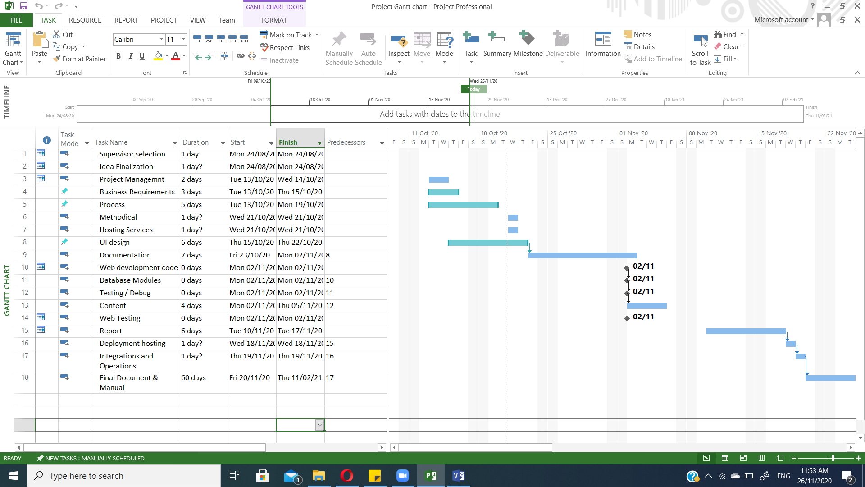

Figure 2 : Gantt chart

## Report Outline

* Requirements and Interviews survey for the website is done in 20 days
* Documentation is going to written in two semesters
* Coding process and implementation is done in around 5 months
* Testing , debugging and runtime process and functionality is check when all the coding phase is done and website is ready

# Chapter 2

# Software Requirement Specifications



## Introduction

## Purpose

This website is for online Shopping. Website is easy to access and reliable for shopping and available 24/7. This website is use for Cloths shopping online any time anywhere from all the different brands available. Special purpose to design such a website is that there is no such website available that ha a verity of clothing brands.

## 

## Document Conventions

This record is. Its degree is to portray the necessities of the Grocery Store and its affiliations. This report has been composed after the Grocery Store and consider that future changes to this program ought to be incorporated into this prerequisites determination record for keeping up its helpful part. To the extent the program usage is concerned while it’s not been actualized, this record can be utilized as manual for improvement of framework. CSS, VCSS property, descriptor, and pseudo-class names are specify by single quotes. Values are specifying by single quotes. Document language element names are in upper case Letters. Document language attribute names are in lower case letters and specify by Double quotes.

## Intended Audience and Reading Suggestions

Users:

The Website is Innovative. The document will helps user to get the features details and functions available in the site and security options. The goal of website is to fulfill the require of time and provide an ease towards clothing shopping that is time consuming and not easy to view more in short time.

Project Manager:

This document will provide all the necessary information about all the project such that what the project is and how they are doing that project and what are the goals they are going to achieve.

Developers:

It will helps the developers to make the product as described such as in use cases, ERDs, class diagrams, DFD etc.

## Product Scope

Online shopping store is a website for clothing shopping for all. It provides easy access any time for shopping and that reduces the time and efforts to buy clothes from market. This website will also help the small business owners that don’t have their websites and provide them a plat form to have good sales.

Customer register them self to buy products and do shopping from their selected brands and also buy from selecting the price range and dress type that will show are the results according to that and the other site admin will also have their logins and the vendors on the site have their own admin sites to manage their shops

## References

IEEE Standard Format used for References in Documentation.

## Overall Description

## Product Perspective

Online shopping website will provide a new plat form for buying cloths and also new for the vendors to sale their products that don’t have their own online selling websites and also for those that have their websites but they are not too much common for the customers and on website their also popular brands available for the customers. This site will reduce the time for shopping and you can see more cloths in your range at one place.

## Product Functions

User on the website can register them self for shopping and saving the details of their orders and select different products and also selection by the price range. Venders have their admin panels to view all details and orders of their store and to manage the products on the website that they are offering and they also have their logins towards admin panels and the Admin of the site can view both the activates done by the venders as well as customers and have the rights to take action any time.

## User Classes and Characteristics

User:

* User knows that login is mandatory to place order
* User can view products and select category
* They can view all the website features
* They all are familiar with the terms and conditions
* They can place order and view status

Administrator:

* Admin has access and control on all activates on website
* Authentication is necessary for admin
* Admin of the site can register users and venders
* Login rules and terms or conditions are also decided by the admin

Vender:

* Login panels for admin sites
* Manage site
* Validation and polices agreed
* Details of order and delivery order on all terms and conditions

## Operating Environment

The website is totally dynamic and can be access from any browser and on any screen size like on laptop mobile tablets etc. website is for all the operating system Windows, Mac and android. Internet connectivity is mandatory to access the website and to place order.

## Design and Implementation Constraints

Design and implementation Constraints for the Website of online shopping store are following

* System have Internet connection to access
* Operating system can use any to access the website that have browser to search
* MySQL Database is use to manage all the records and details
* Laravel Frame work is use to develop the project
* HTTP / HTTPS protocols use to access
* Back end of the web site is design in PHP language

## User Documentation

This Website will help the end users to solve the issue of shopping from different brands in short time or do shopping from home and get the best product. Moreover, it will help the local as well as short brands that have less customers on their shops and they also improve the sales and clients. User can contact with the sellers and get more information or any query regarding the product discussion. Their also contact service available for the user to get help or anything facing issue can be solving.

## Assumptions and Dependencies

Assumptions and Dependencies to use the website are given below for users

* User must have the basic knowledge for shopping and polices
* User have basic knowledge to use system and mobile to access the website
* Venders must follow the rules and polices that are got signed when user get register
* Admin Monitors all the activates done on the website
* Terms and conditions and polices must be follow by all the users

## External Interface Requirements

## 

## User Interfaces

Home Page:

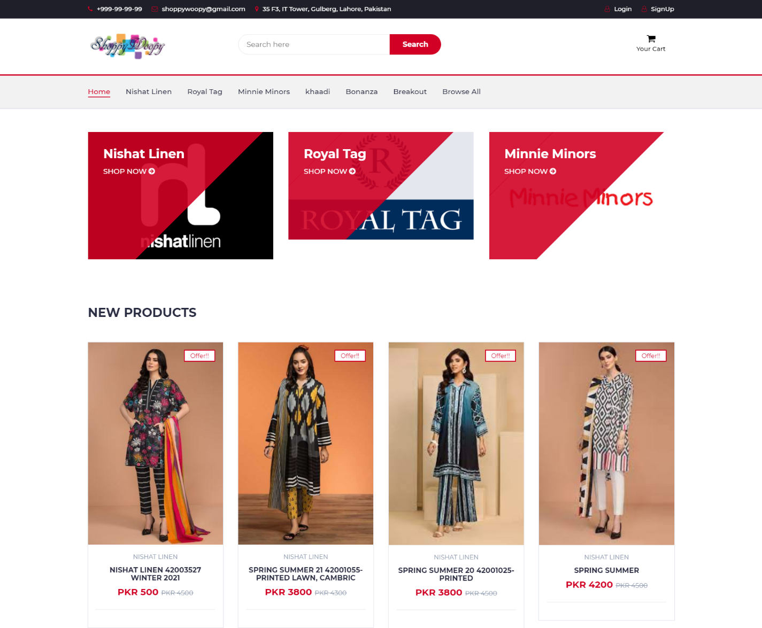

Figure 3 : Home page Interface

**Checkout:**

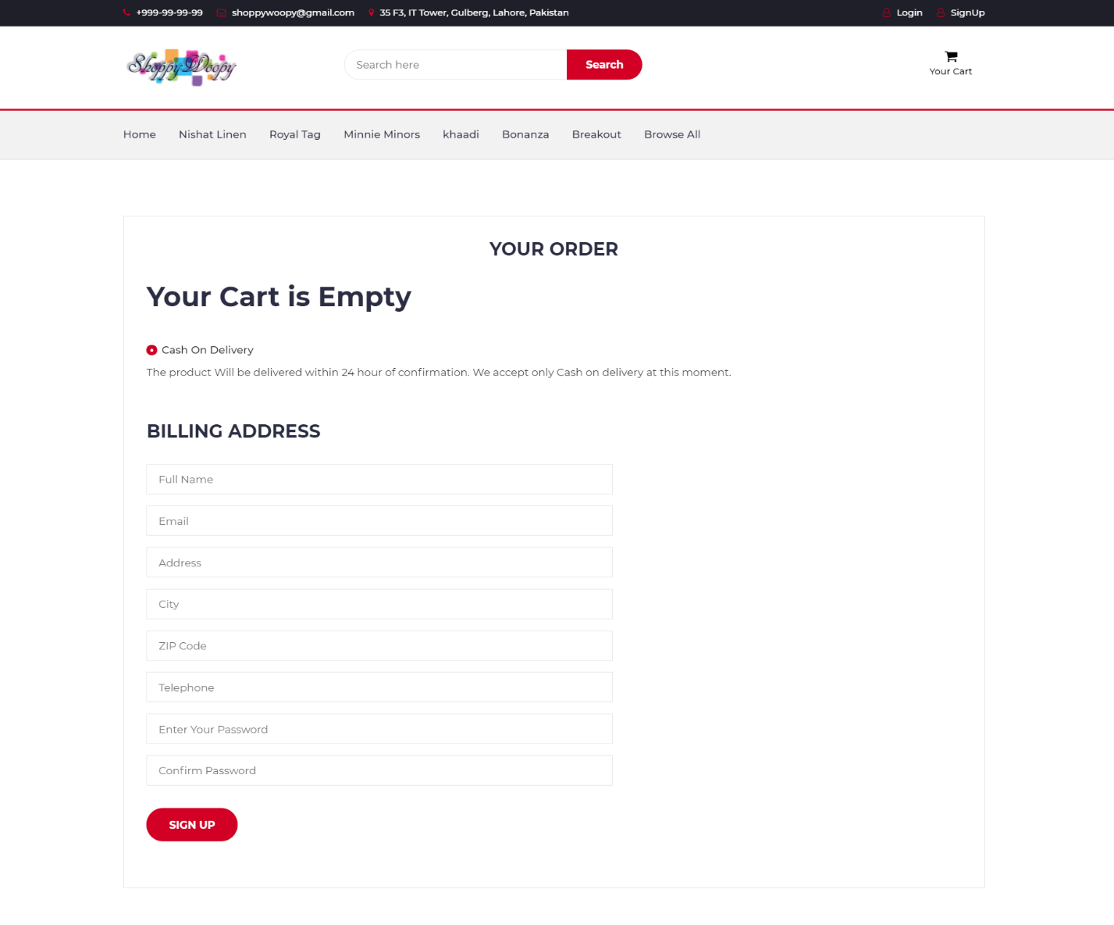

Figure 4 : Checkout Interface

**Login Register:**

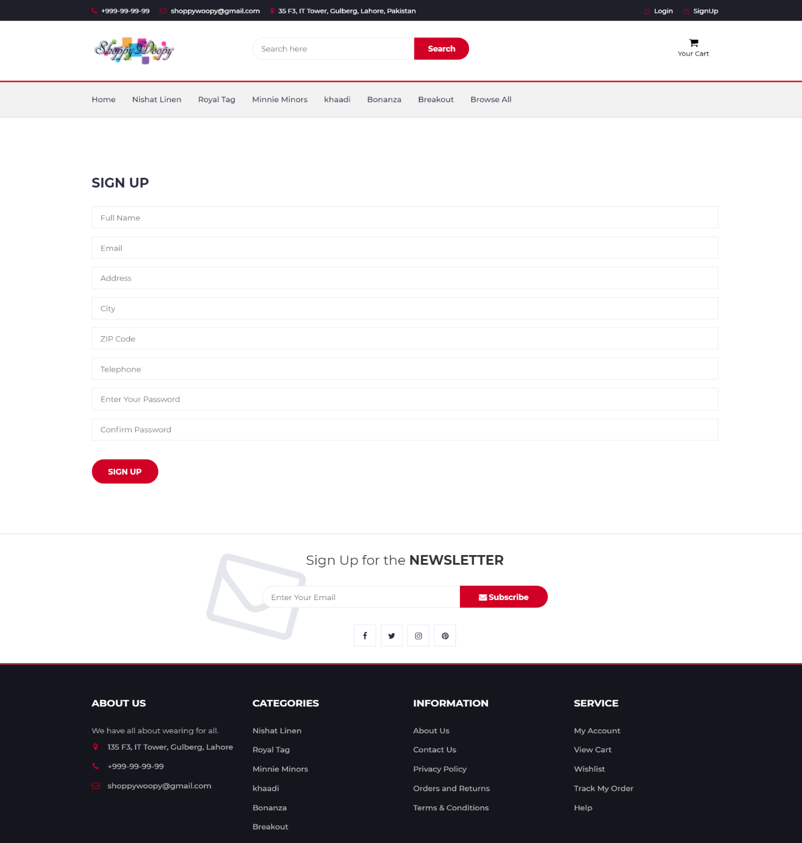

Figure 5 : Login and Register Interface

**My Account:**

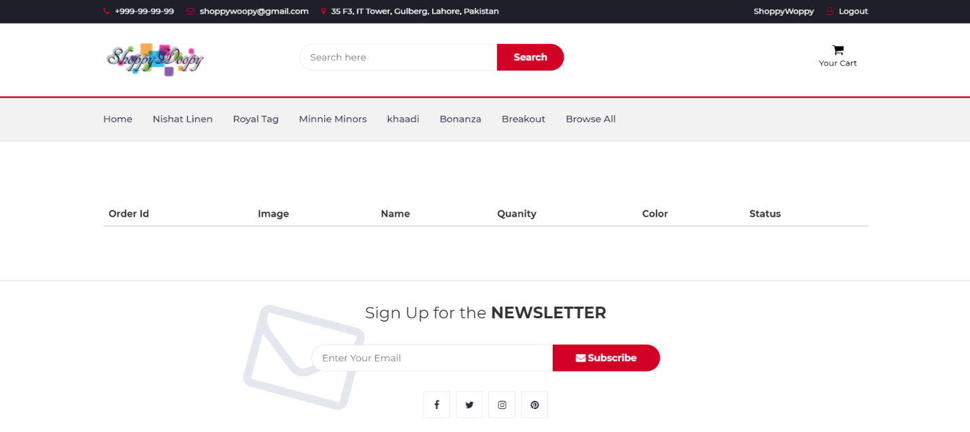

Figure 6 : My Account Interface

**Admin / Venders login:**

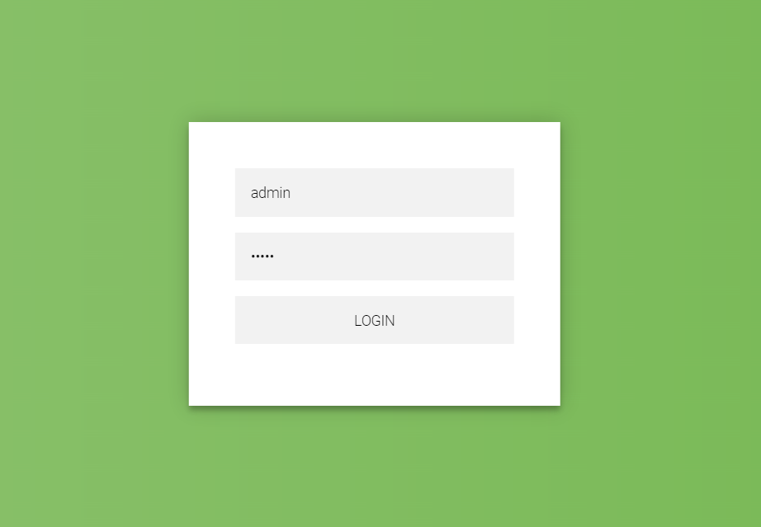

Figure 7 : Admin and Venders login

**Admin / Vender Dashboard**

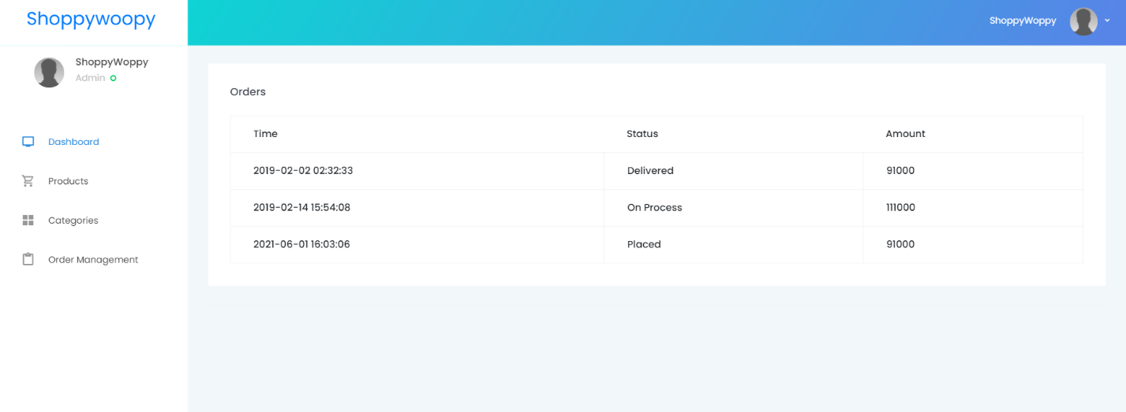

## Hardware Interfaces

This is an online website that needs to access all over through internet so the requirements for the website are given

* Wan, Lan , Routers and other network devices connection to access the internet
* Browsers in system and mobiles and other devices to access the website
* Browsers must support HTML & JavaScript

## Software Interfaces

Software interaction of the website with the following

* Communication of the website can be done from windows, Mac and android devices
* Database Interaction and data CRUD operations are performing on MySQL
* User Interaction is with GUI that is designed in Front end languages used to develop the interface of website i.e. HTML, Css, JavaScript, Boot Strat etc.

## Communications Interfaces

The Online Shopping supports all types of browsers and Communication is done through HTTP / HTTPS protocol over the internet and internet communications between servers and databases are done through TCP/IP protocols.

## System Features

Website contain multiple pages and have Different features

## Login/Logout

## Description and Priority

Login/Logout Validation is most important feature in the website for all the users’ admin and venders on the site. This feature will help to get the details and to give access to right person to manage their activates and also helpful for the admin to maintain the record against the user names and id provided to that account. This is High priority feature because without login user cannot place order without login admin or vender cannot make any kind of changes in whole website.

## Stimulus/Response Sequences

* When any user comes on website there is a Login button at top
* On click the button there is Login page containing two fields for user email and password
* Then there is login button which redirect the user to home page
* For admin site or vender site there is main screen contain email and password form to login make redirect them to their panels.

## Functional Requirements

REQ-SF1-1: Email and password should be valid for registration

REQ-SF1-2: Every time login Must enter the registered email and password when Signup

REQ-SF1-3: Password is hidden and have mix characters and numeric words

## Email

## Description and Priority

Email is send to the user when they place order. Email contains all the details of their order and also the delivery details and tracking number against that order and Product price image that helps the user to check that what he place order and check tracking in case of late in delivery.

## Stimulus/Response Sequences

* User have to place order
* Email is send for confirmation of order with details on the provided email by the user

## Functional Requirements

REQ-SF2-1: Provided email must be valid

REQ-SF2-2: User get details and tracking from email

## Message Service

* + - 1. **Description and priority**

Message is send to the user for validation of number provided with OTP when the user sign up on the website and on this number when the user place order it will receive the conformation message of the order

* + - 1. **Stimulus/Response Sequence**
* After providing all information click on signup button
* OPT again number generated and send
* Write the OPT to conform the Phone number
* Account Created successfully
  + - 1. **Functional Requirements**

REQ-SF3-1: Phone number should be valid and in use

## Other Nonfunctional Requirements

## Performance Requirements

Our store service was available at 24/7. We have two servers if one down then automatically converts into second server to insure the availability of website 24/7.In order to maintain an acceptable speed at maximum number of uploads allowed from a particular customer will any number of user access can access the system at any time. Also connections to servers will be based in criteria of attributes of the user. Into our site, signup is compulsory for shopping.

## Safety Requirements

The products purchase from our store also have the manual inside how to use it and in case of any damage or Loss Company will not be responsible. You must check your product within 48 hours after receiving. In cash on delivery pay the exact amount to the delivery person after receiving the product.

## Security Requirements

There needs to be clearly defined roles of the users. These roles are 'customer’ and 'administrator'. Each person that goes to the system's website will be required to register if they want to do more than just read / browse site content. A secure server will be required to ensure confidentiality of customer’s credit card and other details because of the different roles, passwords and user accounts must be implemented properly. It should be difficult to gain access to the site in an illegal manner. Vendors must have to provide their permanent address of shops and for return their valid CNIC and contact details.

## Software Quality Attributes

The online shopping store will provide you the best software quality and easily understand by our customers how to buy a product from the site and how to pay the bill. You can use it on any operating system which have internet and the web browser to access the site.

## Business Rules

* To perform any activity validation is mandatory
* Venders must provide their exact shop location and contact details
* For venders their CNIC and their Shop address is compulsory for registration
* One vender CNIC contains only one shop
* Admin of the site can have view to all the venders and users
* User can place order and return within 7 days
* All the users , venders and Admin must Follow the terms and conditions

## Other Requirements

* Quality

Quality of the ordered product must be same as described in the details of the product by the vender

* Security

All information provided by the users must be secure

* Safety

Safety make ensure that the admin have to monitor all the activates

# Chapter 3

# Use Case Analysis

**Chapter 3:** System Analysis

## Use Case Model



Figure 8 : Use case Diagram

## Use Case Descriptions

* **Customer Use case Description**

1. Login

The customer can login if he/she has already signup their account.

1. Sign up

For the first time, customer can signup their account.

1. Register

Customer can register their account to proceed their order.

1. View Products

Customer can view products randomly and also search by their categories

1. Add to cart

Customer can choose their products and add into cart.

1. Place order

Confirm order and receive a mail

1. Bill

After checkout you can see your total bill .

1. Payment

Payment method selected via jazz cash , debit card or cash on delivery

1. View Status

After confirm their order the customer can view their status

* **Admin use case description**

1. Login

When admin comes on admin panel then he can login can their side

1. Sign up

When admin comes on first time to sale their things then he can sign up their account.

1. Delete customer and Manager

Admin can delete their customer and manager

1. Add customer and Manager

Admin can easily add their customer and manager

1. Edit customer and Manager

Admin can edit their customer and manager.

1. View all customer and Manager

Admin can view all customer and manager

1. Search customer and Manager

Admin can search their customer and manager easily

1. Manage order

Admin can manage their order

1. View orders

Admin can view order and easily manage

1. Manager stock

Admin can manage their stock according to their order

1. Search products

Admin can search their products to manage their stock

1. Place order

When order comes on site, Admin can view and place order to proceed further

1. Payment

Admin can receive payment through jazz cash, bank transfer and supplier

* **Vender**

1. Add product details

Vender can add products and their details on shop that are display on website

1. Fulfill order

Vender fulfil the required order placed by the customer

1. Receive payment

Vender receive payment after certain time period

1. Manage stock

Vender manage their stoke to make sure that they have all the products in stock

# Chapter 4

# System Design

**Chapter 4:** System Design

[Paragraph Text 12 pt, Calibri, 1.5 Line Spacing, Justified]

[*Between 4 to 8 lines describe what is this chapter all about*]

The Chapter is about how the product will function and by what means will the cycles be executed as we see we have a few outlines that shows how truly is the framework performing also, what will be the prerequisites to play out the activities required undertakings just as the outlines and information plainly depicts the cycle and shows an extraordinary assistance in comprehension the

## Architecture Diagram

[Paragraph Text 12 pt, Calibri, 1.5 Line Spacing, Justified]

Architecture Diagram is the graphical representation of Online Shopping Store that how the system actually works.



Figure 9 : Architecture Diagram

## Domain Model

[Paragraph Text 12 pt, Calibri, 1.5 Line Spacing, Justified]



Figure 10 : Domain Model Diagram

## Entity Relationship Diagram with data dictionary



Figure 11 : Entity Relationship Diagram

## Class Diagram



Figure 12 : Class Diagram

## Sequence / Collaboration Diagram

Customer:



Figure 13 : Customer Sequence Diagram

Admin:



Figure 14 : Admin Sequence Diagram

Vender:



Figure 15 : Vender Sequence Diagram

## Operation contracts

Operations contracts written against the Sequence Diagram

**Customer**

**Operation Name:** Browse Website

**Cross Reference:** Use case: Customer

**Pre-condition:** Internet connection

**Post condition:** on click name website loads and home page/ login page display

**Operation Name:** Login

**Cross Reference:** Use case: Customer

**Pre-condition:** Registered username and password

**Post condition:** Login Instance LI has been created for user login operation.LI was associated with user (Association formed)

**Operation Name:** View Products

**Cross Reference:** Use case: Customer

**Pre-condition:** None

**Post condition:** Select any category of customer can view all products

**Operation Name:** Cart

**Cross Reference:** Use case: Customer

**Pre-condition:** Select product

**Post condition:** Selected product add to cart and associated with user id

**Operation Name:** Checkout

**Cross Reference:** Use case: Customer

**Pre-condition:** Items must be select to checkout

**Post condition:** Total amount is displayed along with products and have to select the payment method

**Operation Name:** Payment

**Cross Reference:** Use case: Customer

**Pre-condition:** On click checkout

**Post condition:** Payment methods that the website is offering is displayed and user select one option against that order

**Operation Name:** Place Order

**Cross Reference:** Use case: Customer

**Pre-condition:** Payment method selected

**Post condition:** order is conform and placed and the user will receive a conformation email and message shortly

**Admin**

**Operation Name:** Login

**Cross Reference:** Use case: Admin

**Pre-condition:** Valid user name and password

**Post condition:** Redirect towards admin panel of the website

**Operation Name:** View venders

**Cross Reference:** Use case: Admin

**Pre-condition:** None

**Post condition:** Display all the venders and their details

**Operation Name:** View Users

**Cross Reference:** Use case: Admin

**Pre-condition:** None

**Post condition:** Display all the registered users on the website

**Operation Name:** Orders

**Cross Reference:** Use case: Admin

**Pre-condition:** None

**Post condition:** View all the details of places orders by any user to any shop

**Operation Name:** Payment details

**Cross Reference:** Use case: Admin

**Pre-condition:** On click payment methods working

**Post condition:** Display all the methods that are allow to users to select

**Operation Name:** Other activates

**Cross Reference:** Use case: Admin

**Pre-condition:** None

**Post condition:** this will display the delivery details feed backs and other status and ways and mediums of delivery

**Vender**

**Operation Name:** Login

**Cross Reference:** Use case: Vender

**Pre-condition:** Registered vender

**Post condition:** Redirect towards vender area to manage

**Operation Name:** View Orders

**Cross Reference:** Use case: Vender

**Pre-condition:** On click orders

**Post condition:** Display all the orders placed with status

**Operation Name:** Fulfill Orders

**Cross Reference:** Use case: Vender

**Pre-condition:** None

**Post condition:** Send the product to customer that he order

**Operation Name:** View Products

**Cross Reference:** Use case: Vender

**Pre-condition:** On click all products

**Post condition:** Display products that they added on their shop

**Operation Name:** Add products

**Cross Reference:** Use case: Vender

**Pre-condition:** on click add new product

**Post condition:** Display the form of details and fields to enter about product

## Activity Diagram

Activity diagram for Online Shopping store

**Customer:**



Figure 16 : Customer Activity Diagram

**Admin:**



Figure 17 : Admin Activity Diagram

**Vender:**



Figure 18 : Vender Activity Diagram

## State Transition Diagram

State transition diagram of online shopping store that how the state changes from one to another



Figure 19 : State Transition Diagram

## Component Diagram

Component Diagram display the components in online shopping store

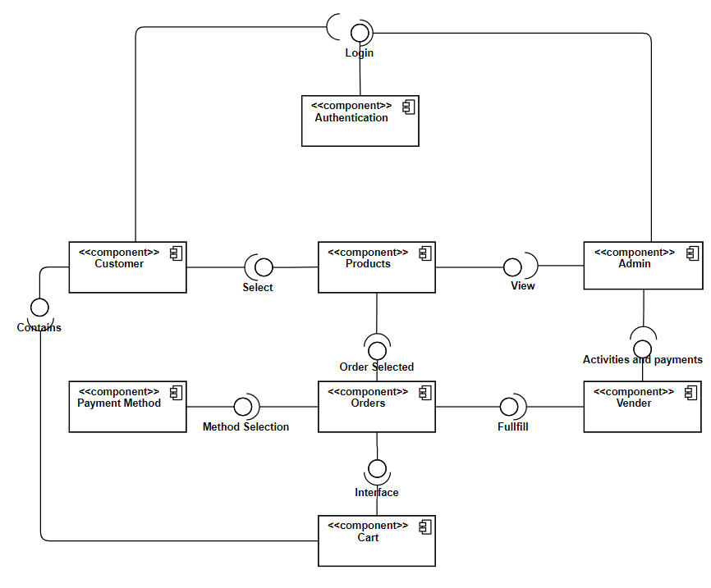

Figure 20 : Component Diagram

## Deployment Diagram

Deployment structure of online shopping website

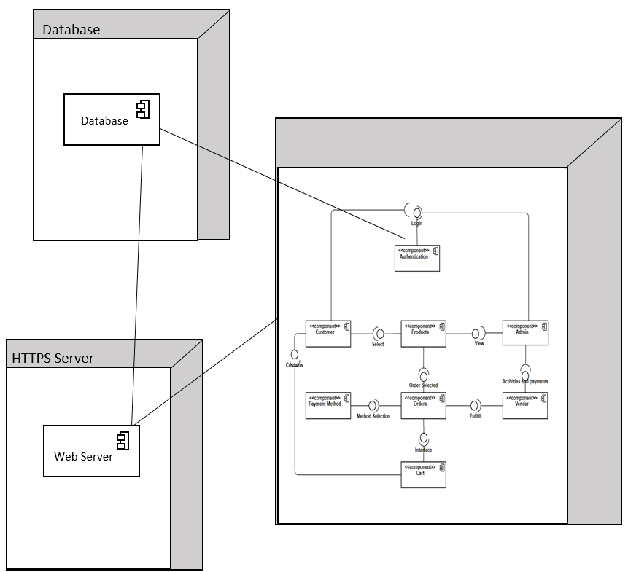

Figure 21 : Deployment Diagram

## Data Flow diagram [*only if structured approach is used - Level 0 and 1*]

Level 0



Figure 22 : Data Flow Diagram Level 0

**Level 1**

**Login:**



**Products:**



**Order:**



**Payment:**



**Place order:**



**Level 1**



Figure 23 : Data flow Diagram level 1

# Chapter 5

# Implementation

**Chapter 5:** Implementation

In this chapter we are going to discuss that in which tool we are building our project and what are the languages that are going to be used to develop the website for front end and the back and the data storage of the website i.e. database. We also discuss the flow of the project and development environment.

## Important Flow Control/Pseudo codes

Customer

* Customer checkout
* Check for login session
* If Customer login proceed to payment
* Else Show login/signup page
* Then select payment method
* Proceed to order

Admin

* View venders details
* View feedback and ratings
* If more than 3 promote then
* Else notify an email for progress

Venders

* Registration is required for Venders
* Admin will Approve The vender
* If yes then allow to access Panel
* Else contact or email for verification to validate

## Components, Libraries, Web Services and stubs

**Components:**

## Responsive design

## Understandable and Remarkable Logo

## User-Friendly

## Good and usable Shopping cart

* Clear Logo of the company on the website.
* Promos and Offers
* Branded Products on the top
* Sign Up and Shopping Cart
* Displaying the Payment options available

**Libraries**

In Project we are using Laravel frame work. Libraries that we are including are given bellow

* [Email-validator](https://www.cloudways.com/blog/php-libraries/#email-validator)
* [OAuth 2.0](https://www.cloudways.com/blog/php-libraries/#oauth)
* [Laravel Backup](https://www.cloudways.com/blog/php-libraries/#laravel-backup)
* [Laravel Cashier](https://www.cloudways.com/blog/php-libraries/#cashier)
* Laravel User Verification

**Web Services**

* XAMPP

## Deployment Environment

In deployment environment we work on **Sublime text or visual studio code** for coding and using **Laravel** framework

For the development of online shopping store and MySQL database to store our data

## Tools and Techniques

Tools and techniques using in online shopping store are given below

Table 2 : Tools and Techniques

|  |  |
| --- | --- |
| Frame Work | Laravel |
| Frontend languages | HTML, CSS, Bootstrap, JavaScript, JQuery |
| Backend Languages | PHP |
| Database | MySQL |
| Coding | Sublime Text, Visual studio code |
| Documentation | MS Word |
| Diagrams | MS Visio |

## Best Practices / Coding Standards

Online shopping store is created by the World Wide Web consortium (W3C), web coding standards are technical guidelines and specifications for building website.

**HTML/CSS**

There is HTML and CSS in all the web pages

**JavaScript**

All the events and in pages events and changes are done by JavaScript

**JQuery**

All the functions for moving up and down and animations are done with JQuery

**PHP**

Backend functionality is written in PHP language

## Version Control

In this Project we are using GitHub for version control and all the collaborative working with the team that we have multiple pages and modules in this project as working on frame work

# Chapter 6

# Testing and Evaluation

**Chapter 6:** Testing and Evaluation

Use Case Testing is a functional black box testing technique that helps testers to identify test seniors that exercise the whole system on each transaction basis from start to finish. In this we test the functionality of the functions in the website that the results of the functions is all as expected or not.

## Use Case Testing

## 6.1.1

|  |  |
| --- | --- |
| Test Suite ID | TS001 |
| Test Case ID | TC001 |
| Test Case Summary | To verify that by clicking Signup Button Username, Password, Email, Phone and address Stores in Users details In database |
| Related Requirement | RS001: User Should able to Signup |
| Prerequisites | NO |
| Test Procedure | 1. Select the Field In signup form 2. Enter Valid Data 3. Click Signup Button |
| Test Data |  |
| Expected Result | 1. If Username, Password, Email and Phone are Valid Then Store User Data by clicking Signup Button and Successfully Signup as a new user 2. If given Inputs are Invalid then display error message 3. If fields of the Signup form are empty Show Warning must enter then signup |
| Actual Result | 1. If Name, Password, Email and Phone is valid the result is as expected 2. If Name, Password, Email and Phone is Not valid Message displayed 3. If the Fields of the form is not filled a warning Alter Appears |
| Status | Pass |
| Remarks | This Test case Working as described and storing data in Data base |
| Created By |  |
| Executed By |  |
| Text Environment | Windows 10 Google Chrome Browser |

## 6.1.2

|  |  |
| --- | --- |
| Test Suite ID | TS001 |
| Test Case ID | TC002 |
| Test Case Summary | Check Login And Authentication |
| Related Requirement | RS002: User Should be able to Login |
| Prerequisites | Must Have Accounts or Signup First |
| Test Procedure | 1. Enter Username In Username field 2. Enter Valid Password In password field 3. click Login Button |
| Test Data |  |
| Expected Result | 1. On click Login Button If the Username and password is Valid User successfully login 2. On click the Login button if username and password is not valid Message display of invalid user. 3. On click login button if the fields are empty warning display required that field |
| Actual Result | 1. If fields are valid user login successfully 2. If fields are invalid message displayed of invalid user 3. If the fields are empty display waring of required that fields |
| Status | Pass |
| Remarks | This test case is simple and easy |
| Created By |  |
| Executed By |  |
| Text Environment | Windows 10 Google Chrome browser |

## 6.1.3

|  |  |
| --- | --- |
| Test Suite ID | TS001 |
| Test Case ID | TC003 |
| Test Case Summary | Forget Password |
| Related Requirement | RS003: Must Have an account and remember username to find account |
| Prerequisites | Must have and account |
| Test Procedure | 1. On click Forget Password enter username 2. Click on send verification code to phone number 3. Enter code and then enter new password |
| Test Data |  |
| Expected Result | 1. Enter username to find account if valid 2. Verification code send provided phone number 3. Enter verification code then enter new password |
| Actual Result | 1. On click forget password username required 2. Verification code send on phone number 3. Enter verification code then set new password |
| Status | Pass |
| Remarks | Easy to use and reset password |
| Created By |  |
| Executed By |  |
| Text Environment | Windows 10 Google Chrome browser |

## 6.1.4

|  |  |
| --- | --- |
| Test Suite ID | TS001 |
| Test Case ID | TC004 |
| Test Case Summary | Add to cart for order |
| Related Requirement | RS004: Select an item to place order |
| Prerequisites | None |
| Test Procedure | 1. Select a product to buy 2. Click on add to card to place order |
| Test Data | Products selection from different categories |
| Expected Result | 1. Select product for order 2. Click on Add to cart to proceed order |
| Actual Result | 1. Select item for purchase 2. Add to cart button available to add |
| Status | Pass |
| Remarks | Easy to use |
| Created By |  |
| Executed By |  |
| Text Environment | Windows 10 Google Chrome browser |

## 6.1.5

|  |  |
| --- | --- |
| Test Suite ID | TS001 |
| Test Case ID | TC002 |
| Test Case Summary | Adding product to wish list for future purchase |
| Related Requirement | RS002: Add to wish list to buy next time |
| Prerequisites | Must have account login to save your wish list |
| Test Procedure | 1. Select item to buy 2. Click to wish list to buy in future |
| Test Data | Product to buy selected |
| Expected Result | 1. On click wish list item added into wish list of user wish list button is located in the bottom of all products |
| Actual Result | 1. Wish list button is located in the bottom and adds the product in wish list |
| Status | Pass |
| Remarks | Simple and Easy To use |
| Created By |  |
| Executed By |  |
| Text Environment | Windows 10 Google Chrome browser |

## 6.1.6

|  |  |
| --- | --- |
| Test Suite ID | TS001 |
| Test Case ID | TC006 |
| Test Case Summary | Price range selector |
| Related Requirement | RS006:Price range scroll bar to set price range max and min |
| Prerequisites | None |
| Test Procedure | 1. Select the minimum price for the products 2. Select the maximum by click or by scroll |
| Test Data | Use mouse to scroll the price range selector |
| Expected Result | 1. Select the minimum Point by scrolling the mouse 2. Select the maximum point by scrolling the mouse |
| Actual Result | 1. Minimum Price range is selected by scrolling the pointer 2. Maximum price range is selected by the mouse pointer moving on the price range bar maximum point |
| Status | Pass |
| Remarks | Simple and easy to use |
| Created By |  |
| Executed By |  |
| Text Environment | Windows 10 Google Chrome browser |

## 6.1.7

|  |  |
| --- | --- |
| Test Suite ID | TS001 |
| Test Case ID | TC007 |
| Test Case Summary | Payment Method selection |
| Related Requirement | RS007: Select a payment method to pay the bill of purchases |
| Prerequisites | Must select at least one product to pay |
| Test Procedure | 1. Click on place order and payment 2. New window appears with payment methods 3. Select method that suits user 4. And press continue to add details and place order |
| Test Data | Different price products selected to buy |
| Expected Result | 1. On click payment and place order new window open 2. Page contains different payment methods 3. User select one of them and continue to add details |
| Actual Result | 1. On click Payment and place order new page open 2. Methods are provided for the users 3. Must select one of them to continue |
| Status | Pass |
| Remarks | Simple and easy to select and use |
| Created By |  |
| Executed By |  |
| Text Environment | Windows 10 Google Chrome browser |

## 6.1.8

|  |  |
| --- | --- |
| Test Suite ID | TS001 |
| Test Case ID | TC008 |
| Test Case Summary | Place order |
| Related Requirement | RS008: |
| Prerequisites | Payment method selected |
| Test Procedure | 1. After selecting payment method and adding details 2. Click on continue and place order 3. Address and details of the order pop up on the screen with button to place order |
| Test Data | Manually select items and payment method to conform the order |
| Expected Result | 1. Order has been placed when we conform the order and click on place order 2. Oder details has been send to vender and admin also |
| Actual Result | 1. On click place order details pop up on screen with button to place order 2. On click place order has been placed |
| Status | Pass |
| Remarks | Easy and simple procedure step |
| Created By |  |
| Executed By |  |
| Text Environment | Windows 10 Google Chrome browser |

## Equivalence partitioning

|  |  |  |
| --- | --- | --- |
| 1 | Username Is alphabetic | Valid |
| 2 | Username is Alpha Numeric | Valid |
| 3 | Username only Numeric | Invalid |
| 4 | User name contains special characters(*, #, @, -) | Invalid |
| 5 | Password is greater than 8 and less than 16 characters | Valid |
| 6 | Password contains Special characters | Valid |
| 7 | Password less than 8 characters | Invalid |
| 8 | Password contains combination of Upper case lower case alpha numeric and special characters | Valid |
| 9 | Email with @ | Valid |
| 10 | Email without @ | Invalid |
| 11 | Search Products with Alphabets | Valid |
| 12 | Search with numbers | Invalid |
| 13 | Search with special characters | Invalid |
| 14 | Brand Name search with Alphabetic name | Valid |
| 15 | Brand Name search with Numbers | Invalid |
| 16 | Empty Field | Invalid |

## Boundary value analysis

|  |  |  |  |  |
| --- | --- | --- | --- | --- |
| Sr. |  | Partition 1 | Partition 2 | Partition 3 |
| 1. | Password | <=0 Invalid | 8 to 16 Valid | 16 to 99 Invalid |
| 2. | Phone | <=0 Invalid | 1 to 11 Valid | 11 to --- invalid |

## Data flow testing

The connection between one element and another while operate a particular task in during data flow. For example, between the sign up and authorizing procedure and so on

## Unit testing

In unit testing we have affirmed our other panel codes independently by performing various tests and by executing them exclusively, independently on various PCs and they were effectively executed and they performed well.

## Integration testing

Integration testing includes consistently executing the interface for each utilization case with the expectation of uncovering error. An error is included in both of the accompanying cases: A sudden conduct happens on the section of all around arranged user input. The framework doesn't corrupt smoothly under erroneous user input.

## Performance testing

In execution testing a specific certain circumstance is given to the site we should simply say a 1000 clients attempt to login or information exchange simultaneously so how the framework recuperates back effortlessly with complete outcomes. So as per our removed outcomes, around 1000+ individuals had the option to enlist in our site.

## Stress Testing

Stress testing applies ridiculous burden situations—to the purpose of over-burdening the framework till it breaks. The point is to discover how stable your item is by extending it past its transfer speed capacity. Stress testing assesses how an application will act past typical conditions and ordinary pinnacle load.

|  |  |
| --- | --- |
| Activity | Description |
| Signup | User Must Need to Sign up to save the details and to place order |
| Login | User have to login to his/her account |
| Users | 3 types of user and on signup we have to check weather user or vender |
| Search | Search is done by name if user knows the brand name |
| Notification | Notification send on placing orders and updates |
| Reviews / Comments | User view reviews and comments against their products |
| Vender details | User can also check other details of venders about their shop and products |
| Payments | Payments must be select before placing the order |
| Details | Order Details can be check from the User accounts |
| Place order | Conformation of order with details send notifications to the vender to whom order placed by user and also send to admin |
| Logout | User can logout their account |

**Login and register Interface:**

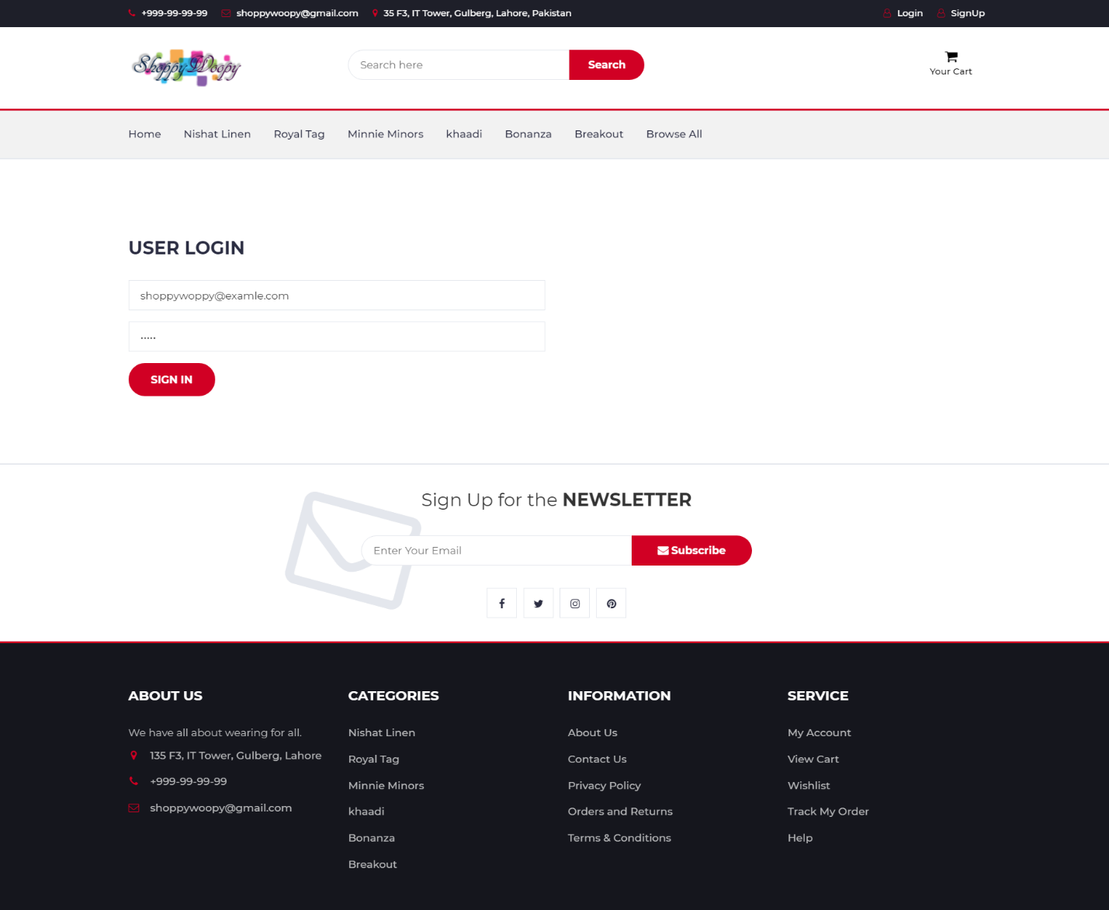

**Register:**



# Chapter 7

# Summary, Conclusion and Future Enhancements

**Chapter 7:** Summary, Conclusion & Future Enhancements

## Project Summary

Now The Project Of online Shopping store is completed and now we explain the main purpose of the Project. This is an online shopping store website in which we have all the branded and local clothing brands. The purpose to develop such a website is to serve the user an ease of shopping from one plat form except of searching again and again for different websites and that make the selection of cloths more difficult and more over if you don’t know the name of such brands you cannot find their sites and buy cloths online we also provide fast delivery and easy return polices to make our clients happy and also give more customer to the business holders. This website brands a platform to buy online cloths of all the brands and local at one place that helps the user to select and buy in short time and make the selection easy. This is the first website that deals only with cloths of all brands and having a lot of features in in.

## Achievements and Improvements

While working on the Project we achieve to enhance our Skills that we lean in our degree and we applied these on our project. Working on the project teaches us how to implement software architecture design techniques, how to use UML modeling, Project management, testing and Implementations of code.

Another Big achievement is that we learn new languages of programming Frameworks, new libraries, Database. These all skills are much more helpful in our future to show our creative thinking in the field.

## Critical Review

Critical element of our Website is that we create simple easy and friendly website to facilitate the user and also best for the sellers we have different panels for user that are separate for customers and admin and venders. We ensure the availability user friendly and fast response website. Website is fully functional and responsive to be used and view at any screen.

## Lessons Learnt

Working on the project in team we learn many things how to work in team. This project help us to improve our skills and provide us a chance to implement these and while implementation we face many problems and how to find solutions for these problems we also learn while doing the project. It also helps us to learn more about framework implementation and managing our whole project in time to deliver the project.

## Future Enhancements/Recommendations

As it has been now said, there is consistently space for additional improvement. What's more, since we intend to dispatch this site as our own startup, improvements will continue to come. The framework has been based on respond local, however sooner or later we work on its productivity, availability, adaptability, we are certainly going to scale it up which we accept our own is in the end going to turn into. We make it more easy to understand interface.

# Appendices

# Appendix A: User Manual

In this section we will describe about our project different interfaces and how to use then and also provide a user manual to use them

**Appendix A:** User Manual

* 1. **Login**

User can login on website by entering the valid user name and password



* + 1. **Register**

User can register itself to purchase anything from the website. Registration is done by entering all the valid data in the required fields



* + - 1. **Home Page**

The first page to be viewed by the user is home page where all the products on site are showing. There is a category on the home page where user can select different brands and there are all other tabs to go for other pages and on top left there are register and login buttons and user profile



# Appendix B: Admin Panel / Venders Panel

In this phase we describe the Admin area of the website and the vender’s area. This is not ass by any of the other user because there is the access of all the website activates.

* 1. **Admin / Venders Login**

Admin / venders can login into panel by entering their valid user name and password



* + 1. **Dashboard**

Main page after login is the dashboard of panel where they have access to all the things and controls of the website and orders and their details and the products showing on the website



# Appendix C: Information / Promotional Material

In this section we design our promotional material for our website.

* 1. **Broacher**

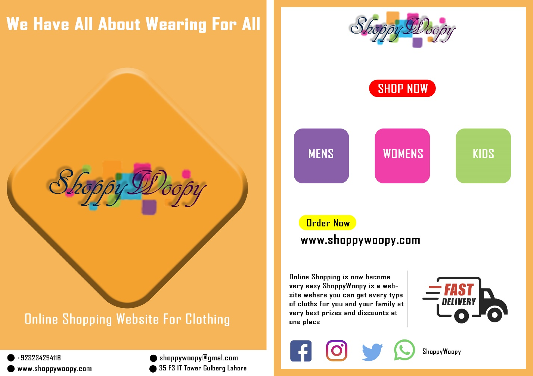

* 1. **Flyer**



* 1. **Standee**



* 1. **Banner**



# Reference and Bibliography

**Reference and Bibliography**

|  |  |
| --- | --- |
| [1] | L. Zhou, "ONLINE SHOPPING ACCEPTANCE MODEL," *Journal of Electronic Commerce Research,* vol. 8, p. 22, 2007. |
| [2] | Y. K. Chung‐Hoon Park, "Identifying key factors affecting consumer purchase behavior in an online shopping context," *International Journal of Retail & Distribution Management,* vol. 31, no. 1, p. 25, 2003. |
| [3] | e. a. Roszi Naszariah Nasni Naseri, "What is a Population in Online Shopping Research?," *Journal of Computer and Mathematics Education,* vol. 12, 2021. |
| [4] | Z. Ahmeda*, "A study on the factors affecting consumer buying behavior towards online shopping in," *Journal of Asian Business Strategy,* p. 14, 2018. |
| [5] | S. Meyer, "bigecommerce," BigCommerce Pty. Ltd. Ecommerce Platform, 2020. [Online]. Available: https://www.bigcommerce.com/blog/covid-19-ecommerce/#changes-in-revenue-across-ecommerce. |
| [6] | "OECD," Tackling coronavirus (COVID-19) - Browse OECD contributions, 2020. [Online]. Available: https://www.oecd.org/coronavirus/policy-responses/e-commerce-in-the-time-of-covid-19-3a2b78e8/. |
| [7] | E. G. C.K.SUNITHA, "Online Shopping - An Overview," p. 12, 2014. |
| [8] | U. Cheema, "THE TREND OF ONLINE SHOPPING IN 21ST CENTURY: IMPACT OF ENJOYMENT IN TAM MODEL," *Asian Journal of Empirical Research,* p. 10. |
| [9] | Ž. Baubonienė, "E-COMMERCE FACTORS INFLUENCING CONSUMERS‘ONLINE SHOPPING DECISION," p. 8, 2015. |
| [10] | S. Prashar, "Effects of Online Shopping Values and Website Cues on Purchase," *The Journal for Decision Makers,* 2017. |
|  |  |